Logarithms  Handout | Name:  Date:

Objective: Logarithmic Expression and Functions

Segment 1: Definition of a Logarithmic Function

The inverse of an exponential function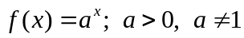 is called the logarithmic function. We write it using “log” notation
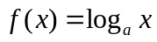

which is read as “log of x to the base a.” Note that the base a of the exponential function becomes the base of the corresponding logarithmic function.
Logarithmic Function Base a
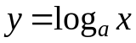 if and only if 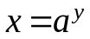
Domain: 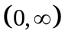 Range: 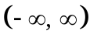

Note! A logarithm is an exponent that the base a is raised to in order to obtain x.

When no base is indicated, the notation logx is interpreted to mean 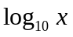 which is also called the common logarithm.

The notation lnx is used to indicate that logarithm to the base e. since lnx is the inverse of the natural exponential function 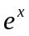, it is called the natural logarithm.

Example-1 Write each logarithmic equation in exponential form.

- 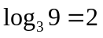

- 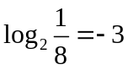

- 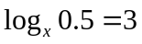

Example-2 Write each exponential equation in logarithmic form.

- 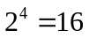

- 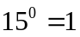
- 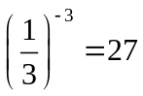

Segment 2: Evaluation of Logarithmic Expressions
Recall that a logarithm is an exponent. For example, if we want to evaluate 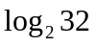, then we need to find the exponent of the base 2 that gives us 32. If we raise 2 to the exponent 5, we obtain 32. Therefore, 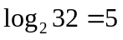

Example-3 Evaluate each logarithmic expression.

- 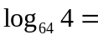
- 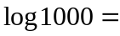

- 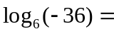

Practice- 1 Write the logarithmic equation in exponential form.

- 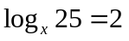

- 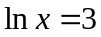

Practice-2 Write the exponential equation in logarithmic form.

- 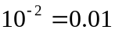

- 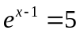
Practice-3 Evaluate each logarithmic expression
a) 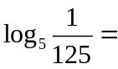
b) 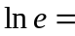

c) 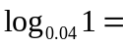

Segment 3: Graphing Logarithmic Functions

While graphing logarithmic functions it is important to remember that the domain of a logarithmic function,
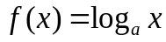, is . Also, in order to obtain integer values for the y-coordinate, you may want to choose values of the x-coordinate which are the perfect powers of the base. For example, if the base of a logarithmic function is 2, then you can let the x be …1/8, 1/4, 1/2, 1, 2, 4, …

Example-4 Graph 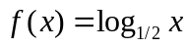. Specify its domain, range, and asymptote.

x | y
1/4 | 2
1/2 | 1
1 | 0
2 | -1
4 | -2

Example-5 Graph 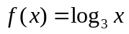. Specify its domain, range , and asymptote.

x | y
1/9 | -2
1/3 | -1
1 | 0
3 | 1
9 | 2

Practice -4 Graph 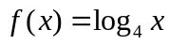. Specify its domain, range, and asymptote.

Practice- 5 Graph 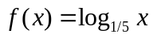. Specify its domain, range, and asymptotes.

Segment 4: Simplifying Logarithmic Expressions Using Properties

Let x and y be positive numbers.
Property 1: 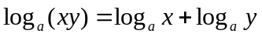
Property 2: 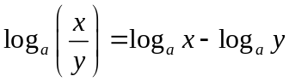
Property 3: 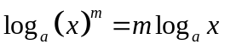

Property 4: 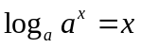

Property 5: 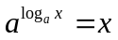

Change of Base Formula
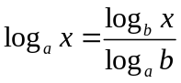

Example 6: Write as a single logarithm with a coefficient 1.
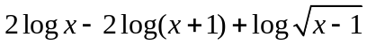=

Practice 6: Write as a single logarithm with a coefficient 1.
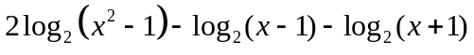=

Practice 7: Write as a single logarithm with a coefficient 1.
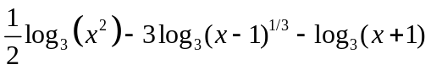

Example-7: Write as a sum and/or difference of logarithms.

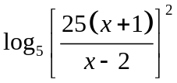

Practice-8: Write as a sum and/or difference of logarithms.

